create user: sudo useradd itiuser1

sudo useradd itiuser1

create group: sudo groupadd os_team

create directory: mkdir os_team_workspace

assign grp to dir: sudo chgrp os_team os_team workspace

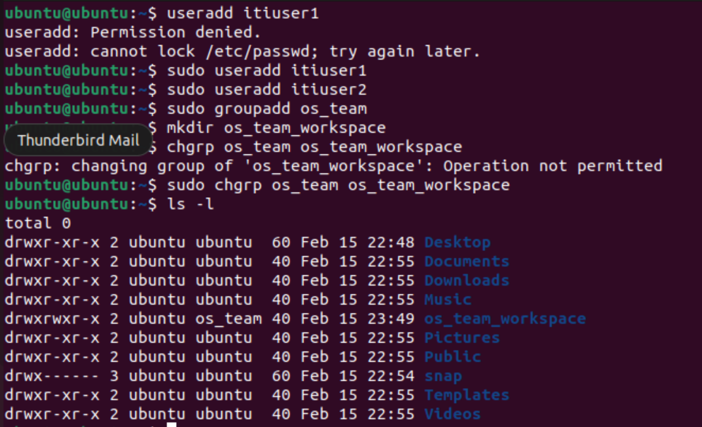

change mod to setgid: sudo chmod g+s os_team workspace

add user to group:

sudo usermod -a -G os_team itiuser1

sudo usermod -a -G os_team itiuser2

change ownership:

sudo chown itiuser1 mydir1

sudo chown itiuser2 mydir2

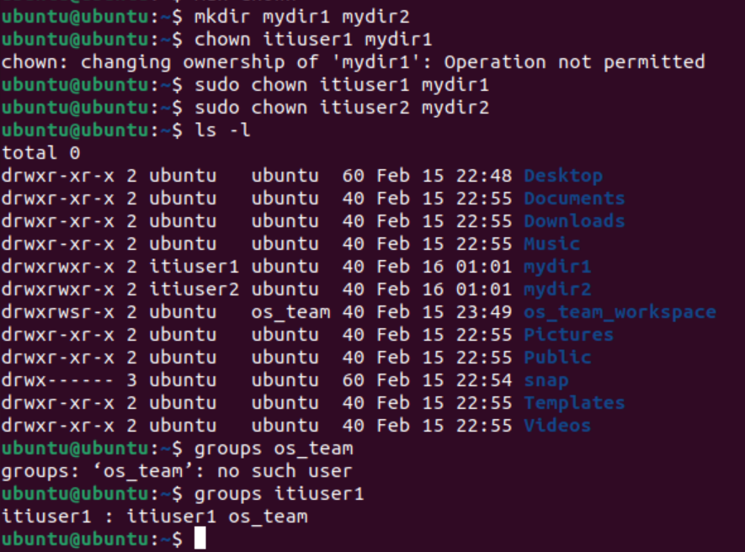

Tree mod:

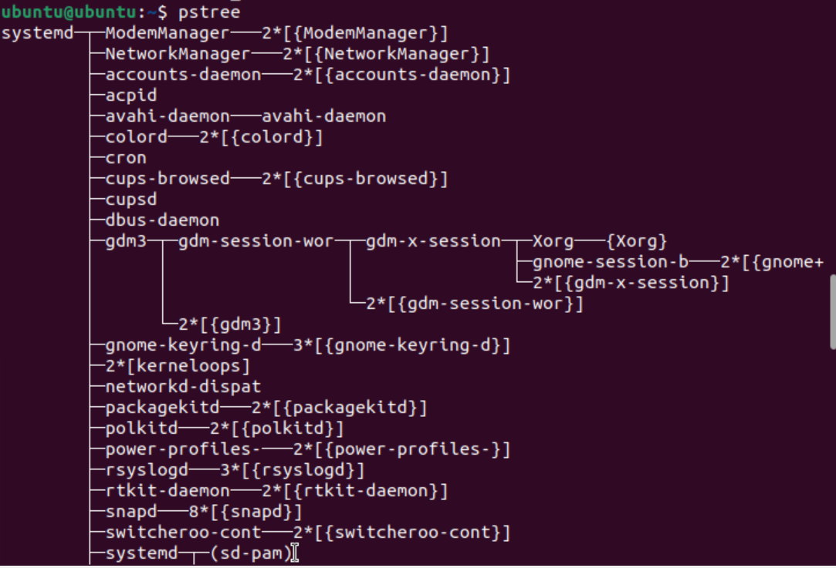

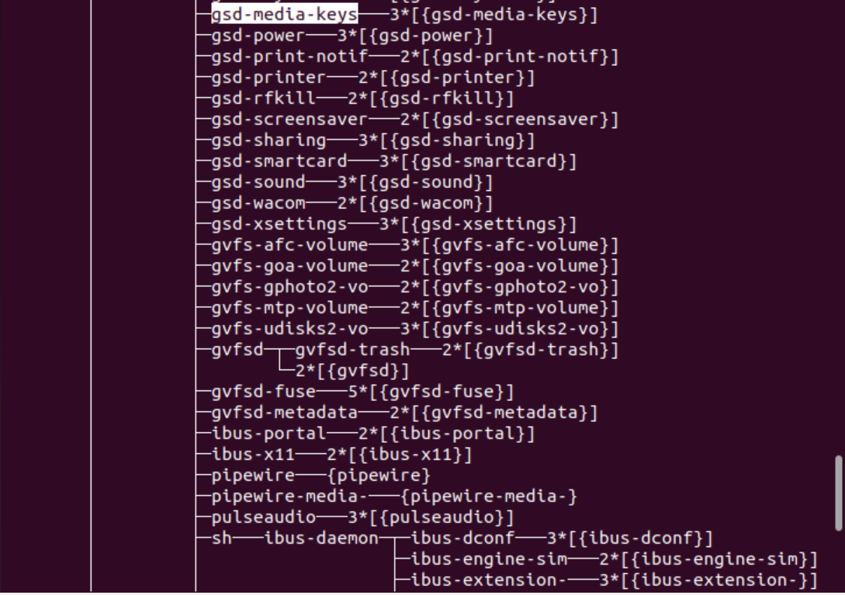

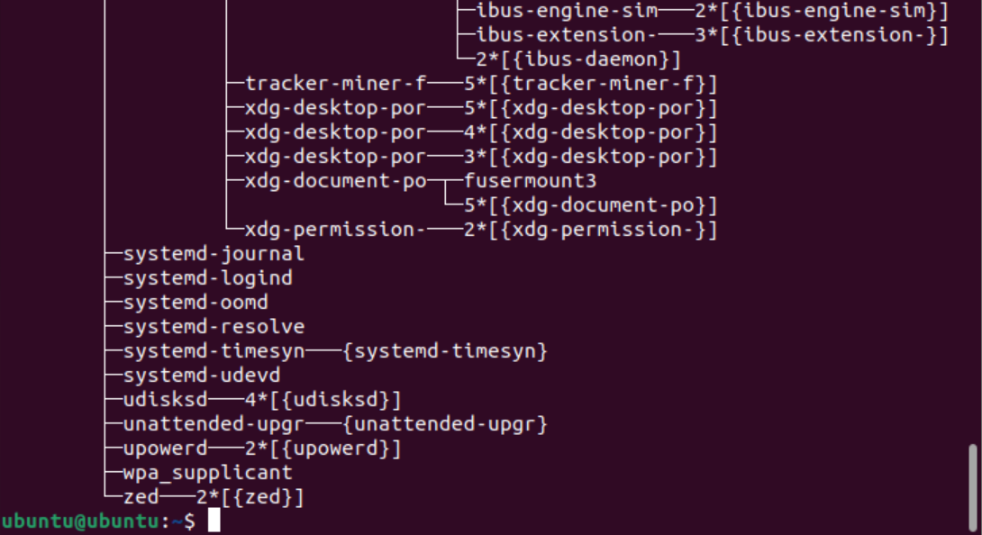

Kill tail:

